**Release Date: 8/14/2025**

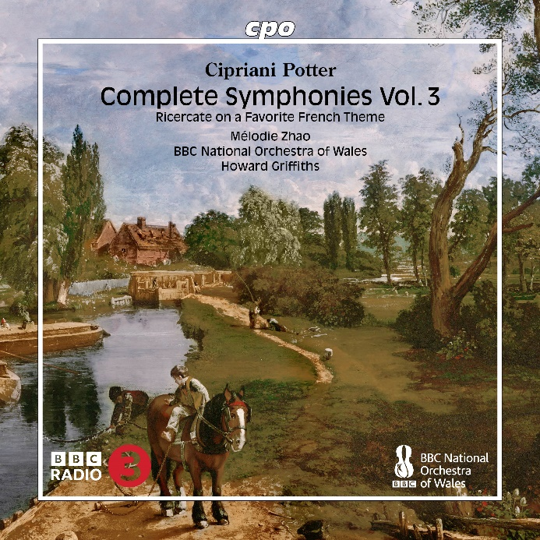

CPO 555 637-2

1 CD

761203563722

Cipriano Potter: Complete Symphonies Vol. 3 & Ricercate on a Favourite French Theme

Mélodie Zhao; BBC National Orchestra of Wales; Howard Griffiths

As a symphonist, the British composer, pianist, conductor, and pedagogue Philip Cipriani Hambly Potter works at the height of his era. He employs an opulent orchestra, drawing his colors from its palette with a remarkably bold brushstroke: Where heavy brass just now steered through breaking waves, delicate flutes and tender strings sound forth the next moment; through dreamy scenes suddenly marches heavy footwork, and when it comes to bringing works to an applause-worthy conclusion, all participants must push to the limits of endurance... This attitude is as fascinating as it is entertaining—precisely the right middle ground between symphonic earnestness and nonchalant playfulness, a welcome facet of early Romantic literature, much like the spirited concert piece that tastefully separates the two symphonies.