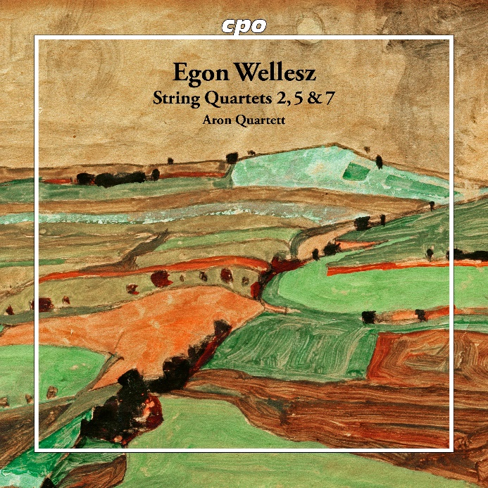

CPO 555 617-2 1 CD
761203561728
Egon Wellesz: String Quartets 2, 5, 7
Aron Quartett

While cpo is currently preparing a box set with all of Austrian composer Egon Wellesz' nine symphonies, the Aron Quartet has begun recording a cycle of his string quartets. This contemporary of Alban Berg and private pupil of Arnold Schoenberg had a remarkable life and career, both in that genre as well as in orchestral music. His career began at the end of the post-Romantic period, whose signs of harmonic dissolution could no longer be overheard, but whose Romanticism was expounded upon in all of its autumnal charm. Later, we witness a constructive reorientation that reveals the strict architectural underpinnings of chamber music without compromise. The interplay, migrations and transformations of motifs, the shifting force fields between the individual voices, the dynamic urge to break new ground – all invite the listener to participate with intensity and fascination.

