Release Date: 10/9/2025

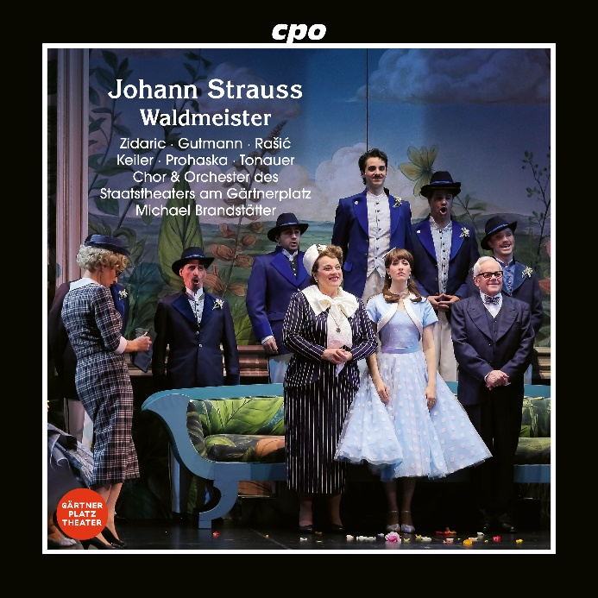

CPO 555 701-2 1 CD
761203570126
Johann Strauss II: Waldmeister (Operetta)
Andreja Zidaric; Daniel Gutmann; Matteo Ivan Rašić; Sophia Keiler; Daniel Prohaska; Anna-Katharina Tonauer; Chor des Staatstheaters am Gärtnerplatz; Orchester des Staatstheaters am Gärtnerplatz; Michael Brandstätter

Just in time for the 200th birthday of Johann Strauss II on 25 October 2025, cpo is releasing the complete recording of a comedy that will itself celebrate its 130th anniversary on 4 December. In Waldmeister, the undisputed king of the waltz once again pulls out all the stops and delivers a delightful comedy whose scandalous mix-ups ultimately dissolve in a high-proof punch. Its distinctive taste features a hero with a botanical title (Galium odoratum) and a series of evergreens – above all the leitmotif and proverbial "Trau schau wem" (Trust, but check), which is enthusiastically taken up by friend and foe alike. This live recording was made during the Staatstheater am Gärtnerplatz's guest performance in Vienna and whose new production contributed to this year's Austrian Strauss celebrations.

