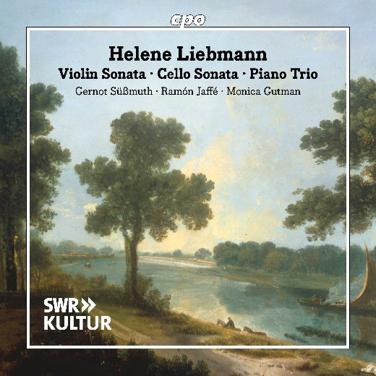

CPO 555 638-2 1 CD

761203563821

Helene Liebmann: Violin Sonata, Cello Sonata & Piano Trio

Gernot Süßmuth; Ramón Jaffé; Monica Gutman

At just ten years old, Helene Liebmann, née Riese, made her public debut as a pianist in Berlin, marking the beginning of a remarkable career. Soon thereafter, her first compositions followed – understandably, works primarily dedicated to her own instrument. Shortly after her marriage in 1814, the young artist relocated to London with her husband, where she studied under Ferdinand Ries, a friend and student of Beethoven. During this time, her earliest chamber music works came into being, followed by additional compositions while in Britain, including the two duo sonatas and the first of two piano trios recorded here. These are all elegant and distinctive works, shifting from the spirit of late Classicism toward the Biedermeier era with a delicate Romantic touch, making them both accessible and enduringly appealing to listeners.