**Release Date: 8/14/2025**

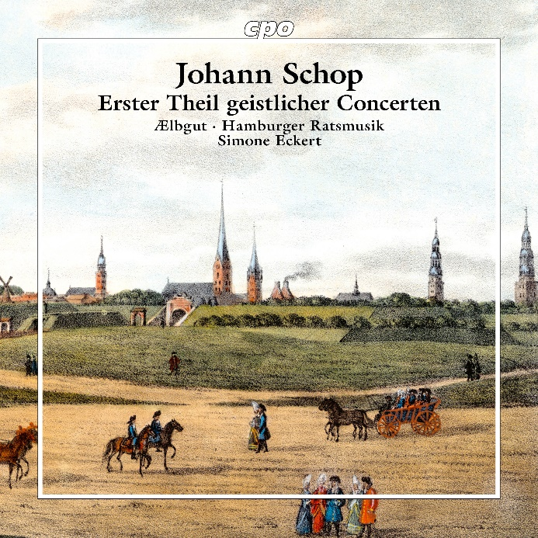

CPO 555 703-2 1 CD

761203570324

Johan Schop: Erster Theil geistlicher Concerten (1643/1644) – Sacred Concertos Part I

AElbgut; Hamburger Ratsmusik; Simone Eckert

Philatelically interested friends of music might be tempted to title this rarity the "Mauritius" of early music, for of the First Part of Sacred Concertos that Hamburg's municipal musician and Kapellmeister Johann Schop published in 1644, only a single complete copy survives in Germany, while the three others traceable worldwide are preserved only fragmentarily. For the value of an artwork, however, different criteria apply than mere rarity, and precisely these Schop's church music fulfills entirely: supplemented by some of the instrumental pieces that the composer and violin virtuoso once played for noble dance entertainments, the filigree, directly appealing song-settings rise in their wondrous weightlessness, full of hope, above the devastating times—here reigns the peace that in reality would wait another four years to arrive.