**NEW RELEASE 22/05/2025**

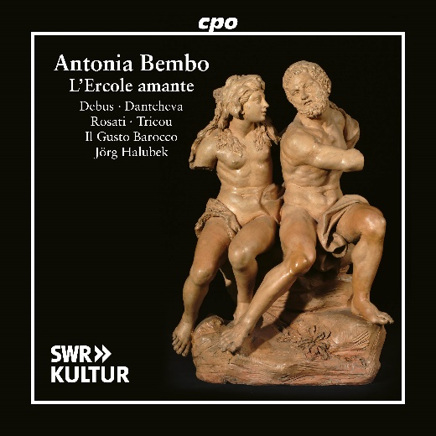

CPO 555 728-2 2 CDs

761203572823

Antonia Bembo: L'Ercole amante (Opera in 5 acts)

Yannick Debus; David Tricou; Anita Rosati; Flore van Meersche; Alena Dantcheva; Arnaud Gluck; Andres Montilla-Acurero; Chelsea Zurflüh; Hans Porten; Il Gusto Barocco; Jörg Halubek

Antonia Bembo’s opera L’Ercole amante waited nearly 340 years for its premiere. This delay may have been due to the subject matter, as her teacher, Antonio Cavalli, had already composed a festival opera based on the same tragedy for the wedding of Louis XIV and Maria Theresa of Spain in 1660. Although the Sun King, reportedly an admirer of her compositions, had taken the Venetian singer under his wings following her separation from her husband and relocation to France, he was already by then quite familiar with the tragic tale of Hercules. And so, he allowed the enchanting and emotionally stirring music, rich with arias, to pass him by. Finally, on May 26, 2023, Jörg Halubek and Il Gusto Barocco brought this long-overlooked masterpiece to its well-deserved breakthrough at Stuttgart’s Liederhalle.