Release Date: 22/01/2026

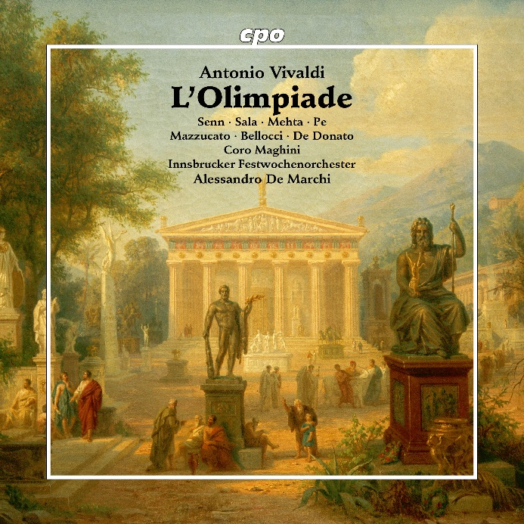

cpo 555 651-2, 3 CD
761203565122

Antonio Vivaldi
L'Olimpiade RV 725
Mazzucato · Bellocci · Sala · Mehta · Pe · Senn · de Donato
Innsbruck Festival Orchestra
Alessandro De Marchi

Almost three hundred years ago, the legendary opera librettist Pietro Metastasio was inspired to write dramatic verse on the Olympic Games, the mother of all festivals. Its perfection was renowned and more than 70 composers set it to music. One of the first of these was Antonio Vivaldi, whose Olimpiade was a great success at its premiere on 17 February 1734 in Venice. Once again, the audience was witness to a brilliant comedy of errors, which was not only based on the ever-popular role reversal, but also brings into play the power of the oracle and the "sportsman's" competition for the hand of a beautiful woman. A happy ending is guaranteed, as was the case at the Innsbruck Festival 2023, thanks to the original production and above all the infectious music of the Prete Rosso Vivaldi.

