Release Date: 06/11/2025

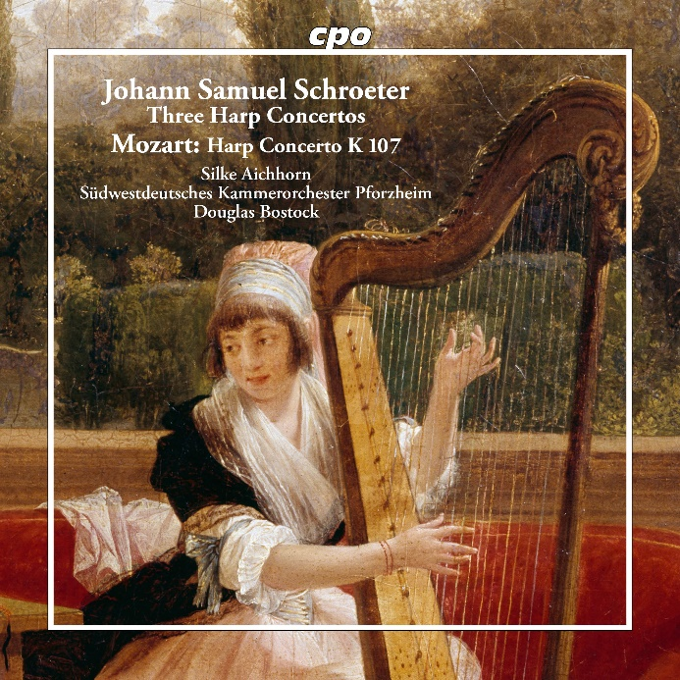

CPO 555 727-2 1 CD
761203572724

Johann Samuel Schroeter: Three Harp Concertos
Wolfgang Amadeus Mozart: Harp Concerto K 107
Silke Aichhorn|Südwestdeutsches Kammerorchester Pforzheim|Douglas Bostock

According to an old tradition, it is perfectly legitimate to arrange works for one instrument to another, if this does not detract from the substance of the work. This is what the young Wolfgang Amadeus Mozart likely told himself when he arranged three piano sonatas by his admired role model Johann Christian Bach into small concertos (KV 107) in his early years. This is also what Silke Aichhorn told herself with equal justification when she arranged one of these pieces for the harp alongside concertos by the German Johann Samuel Schröter, who was almost the same age. The pairing is no coincidence. Mozart and his father both admired the works of Schröter, born in Guben, Lusatia, who enjoyed a distinguished career as a pianist. In 1782, he succeeded the “London Bach” as music teacher to Her Majesty Queen Charlotte – unfortunately not for very long. Schröter died three years before Amadeus and at the same age.

