Release Date: 10/24/2025

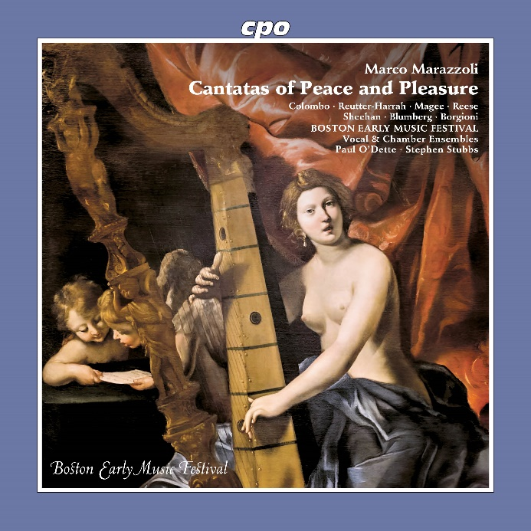

CPO 555 731-2 1 CD
761203573127
Marco Marazzoli: A Garden of Earthly Delights (Cantatas)
Teresa Wakim • Carlotta Colombo • James Reese • Aaron Sheehan • Jesse Blumberg • Mauro Borgioni • Boston Early Music Festival Chamber Ensemble • Stephen Stubbs • Paul O'Dette

Marco Marazzoli was a composer, harpist and singer, and as such moved in the highest circles of the clergy. This was certainly not only due to his own priesthood, but above all to the extraordinary quality of his creations. He was born around 1602 in Parma and died in Rome in 1662. He was successful with large-scale works and in the field of chamber music cantatas. Towards the end of his life, he composed a series of experimental vocal works for six voices and a small instrumental ensemble that even satisfied the demands of Christ's representative on earth. After all, in these miniature dramas, the composer and his poets celebrated the Pope as a man of peace, through whose mediation the Franco-Spanish War had ended in 1659. This recognition can still be felt today.

Christianity in all its forms excels through its high degree of adaptability. We encounter one of the more fascinating examples of adaptation in Latin American Catholicism that developed in the colonies of "New Spain". Not least did the veneration of Mary find especially receptive genius loci here, whose musical disposition soon wedded to an artistic concept that was the non plus ultra for the rulers of the Old World. For some composers, the transatlantic regions thus had such appeal that they abandoned their traditional sphere of activity. One of them was the Italian Ignacio de Jerusalem, who worked at the cathedral in Mexico City; he was joined by the Mexican "home-grown talent" Manuel de Sumaya as well as two Spanish musicians who were only known and beloved in the land of the Aztecs only for their printed works - this yields a truly exquisite mix for Christmas.

