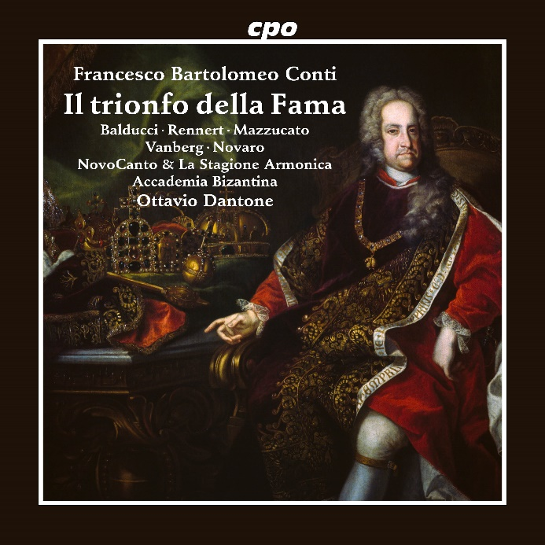

CPO 555 725-2 2 CDs

761203572526

Francesco Bartolomeo Conti: Il trionfo della Fama (Serenata)

Benedetta Mazzucato; Sophie Rennert; Nicolo Balducci; Martin Vanberg; Riccardo Novaro; Novo Canto; La Stagione Armonica; Accademia Bizantina; Ottavio Dantone

On 5 September 1723, Emperor Charles VI, the father of his legendary successor Maria Theresia, was crowned King of Bohemia in St. Vitus Cathedral in Prague. After this magnificent ceremony had already gone on for several hours, the Golden City held a series of festivities that one can hardly imagine today. Among other things, a new work by the Vienna court composer Francesco Conti was performed. The serenata Il Trionfo della Fama, in which the goddess of fame (and rumour) celebrates the ruler of the world together with all parts of the earth known at the time. His Majesty was surely greatly pleased by the one-act opera. With timpani and trumpets, sprinkled with glorious arias for the allegorical figures representing the emperor’s character traits, the "Triumph of the Goddess of Fame" has not lost anything of its entertaining impact even three hundred years after its premiere.