**Release Date: 9/11/2025**

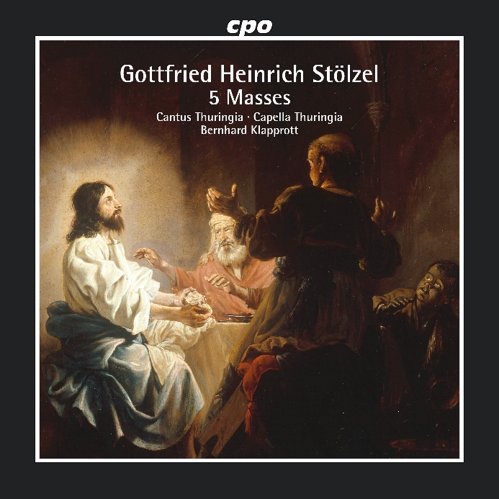

CPO 555 366-2 1 CD

761203536627

Gottfried Heinrich Stölzel: Masses

Cantus Thuringia; Capella Thuringia; Bernhard Klapprott

Five years younger than Johann Sebastian Bach, who survived him by all of eight months, Gottfried Heinrich Stölzel was among those Central German musicians who made a name for themselves beyond their regional sphere of influence. It is no coincidence that the sacred works of Gotha's long-serving court conductor in particular have now found a suitable home in our catalogue. The passions, oratorios and cantatas that have already been released are now joined by five pieces of Protestant sacred music in which the extensive Catholic liturgy is reduced to Kyrie and Gloria. The missae breves selected here confirm once again that their author was ‘one of the most reasonable, learned and great composers’ to whom Johann Mattheson rightly accorded a place of honour in his Ehrenpforte of 1740. All should know.