Release Date: 9/25/2025

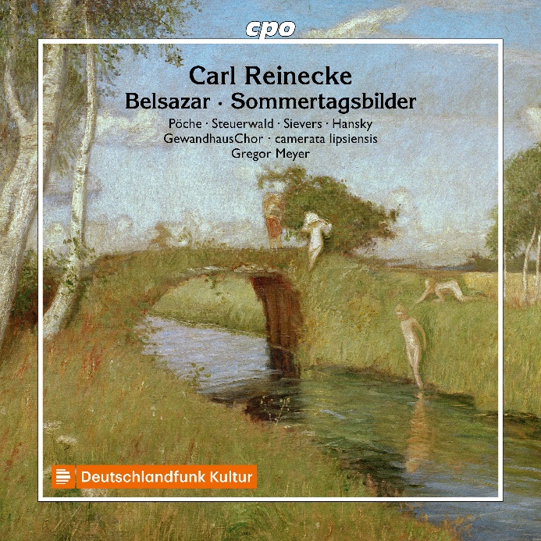

CPO555 692-2 2 CDs
761203569229
Carl Heinrich Reinecke: Belsazar op. 73 (Oratorio)
Anja Pöche; Nora Steuerwald; Florian Sievers; Bernhard Hansky; GewandhausChor Leipzig; Camerata Lipsiensis; Gregor Meyer

Carl Reinecke's works are living proof that conservatism and originality are not mutually exclusive. His work rests on the shoulders of previous generations and nowhere does it depart from the harmonic or formal conventions that were part of the curriculum at conservatoires in the 19th century - and yet we will encounter a personality who did not hide behind formulae, but to a certain extent between the lines and in the details. In his oratorio Belsazar, premiered in 1859, he indulges extensively in the tension between God-fearing Israelites and the brutally blasphemous Babylonians. Some twenty years later, he produced a successful ‘Concert Piece for Choir and Orchestra’ in which vocal movements and instrumental interludes are combined in a novel way to create a unique and unusually poetic sequence of enchanting Sommertagsbilder (Pictures of a Summer's Day). It is an experience in changing moods...

