**Release Date: 8/14/2025**

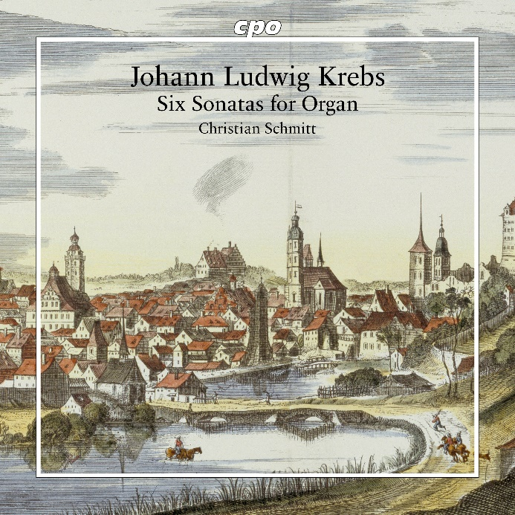

CPO 555 888-2

1 CD

761203788828

Johann Ludwig Krebs: Six Sonatas for Organ

Christian Schmitt

In German usage, it has become customary to refer to older compositions for keyboard instruments—unless explicitly written for harpsichord or organ—as "Clavierwerke" (keyboard works). Since the boundaries were fluid, these sonatas for a pedalless "Clavier" can certainly be interpreted on a suitable pipe organ. The organ at St. Cyriakus Church in Duderstadt offers just such possibilities, despite various modernizations: Created by Johannes Creutzburg between 1733 and 1735, the instrument belongs to precisely the same period when young Johann Ludwig Krebs completed his training with Leipzig's Thomaskantor, Johann Sebastian Bach. In these six sonatas—rediscovered only in 2009—the student speaks a distinctly different language from his teacher: playful, carefree, occasionally "dallying", and always galant are these pieces from his hand.