Release Date: 22/01/2026

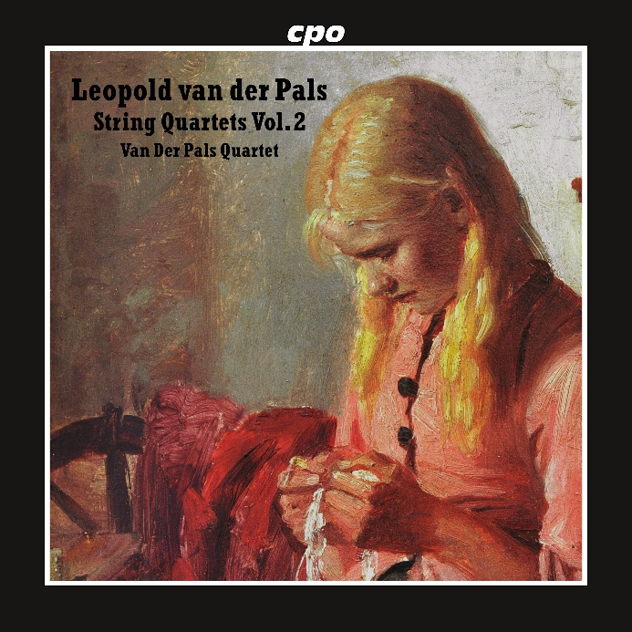

cpo 555 743-2, CD
761203574322

Leopold van der Pals
String Quartets Vol. 2 - String Quartets 4-6
Van Der Pals Quartet

Exquisite music between late Romanticism and Impressionism, which [...] definitely deserves to be heard." There is not much to add to the words of the reviewer who reported on the first part of these complete recordings for klassik-heute. Leopold van der Pals, the son of Danish-Dutch parents, grew up in Russia and spent his life searching for higher truths. His inspirations, Goethe the scientist and his spiritual successor Rudolf Steiner, and his own experiences led him to ever-new explorations of the possibilities of infinite metamorphosis to an all-encompassing state of being. The current release concludes his cycle of string quartets. A bonus track – the melodious, distinctive quintet for flute and strings, where the composer renounces all virtuoso pretensions in a particularly appealing way.

