New Release – January 2026
Release Date Digital: 4th December 2025 

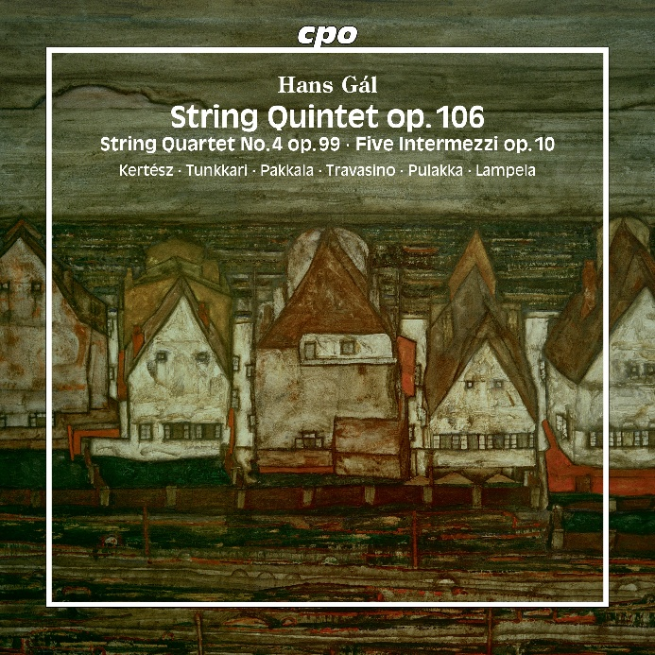

Hans Gál
String Chamber Music
Quintet for 2 Violins, 2 Violas and Cello Op.106 (1976)
String Quartet No.4 Op.99 (1970)
Five Intermezzi for String Quartet Op.10 (1914)
Katalin Kertész & Reijo Tunkkari, violin
Hanna Pakkala & Emiliano Travasino, viola
Lauri Pulakka & Ulla Lampela, cello

cpo 555 721-2
UPC: 761203572120

When Hans Gál died in Edinburgh on 3 October 1987, he had just celebrated his 97th birthday and could look back on a life that had truly experienced personal, cultural and political upheaval. Astonishingly, there is no trace of these often tragic and dramatic events in his music. The core of his output is dominated by the cheerfulness of a spirit who never forgot his artistic home – the old imperial city of Vienna, whose special, inimitable flair can even be seen in his final works. The chamber music for strings collected here are convincing examples of this fidelity to himself. Gál was 24, when his Intermezzi were printed and he was 86, when he completed his transfigured string quintet – and despite all blows of fate, there was obviously nothing that could destroy his optimistic belief in beauty.

