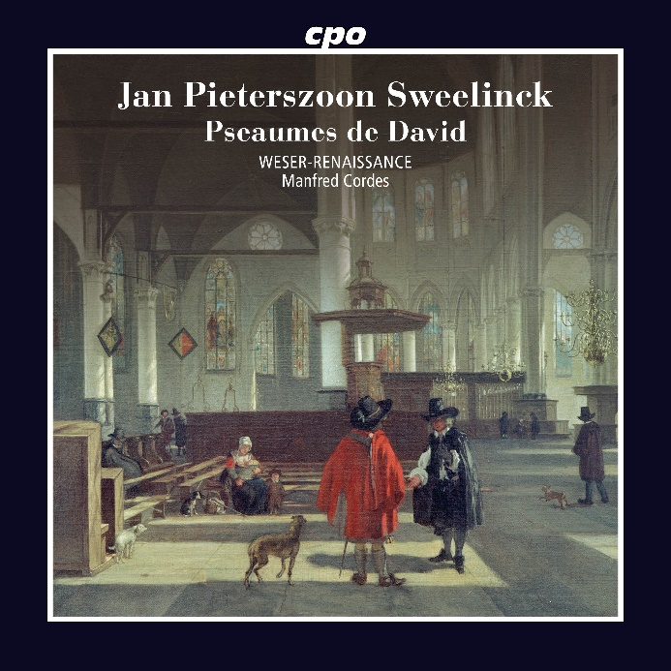

CPO 555 526-2 1 CD

761203552627

Sweelinck: Psaumes de David

Edoardo Bellotti; Weser-Renaissance Bremen; Manfred Cordes

On the path to true faith and its practice to please God, there have been regular heated debates over the role of music. Reactionaries repeatedly closed the lid on excessive cheer. This was also the case in the Netherlands of the 17th century. The reformist spirit of the Frenchman John Calvin led to an almost complete ban of music during worship services, despite the fact that the psalms of David ("Sing unto the Lord") provide unassailable proof to the contrary. Shortly before 1600, the great Dutch composer Jan Pieterszoon Sweelinck discovered how these psalms could be, and were permitted to be, set to new music. The "Orpheus of Amsterdam" succeeded in transforming imposed restrictions into acoustic wonders. Our small selection of psalms, alternating with several organ works, proves once again the victory of the spirit over heavy subject matter...