Release Date: 22/01/2026

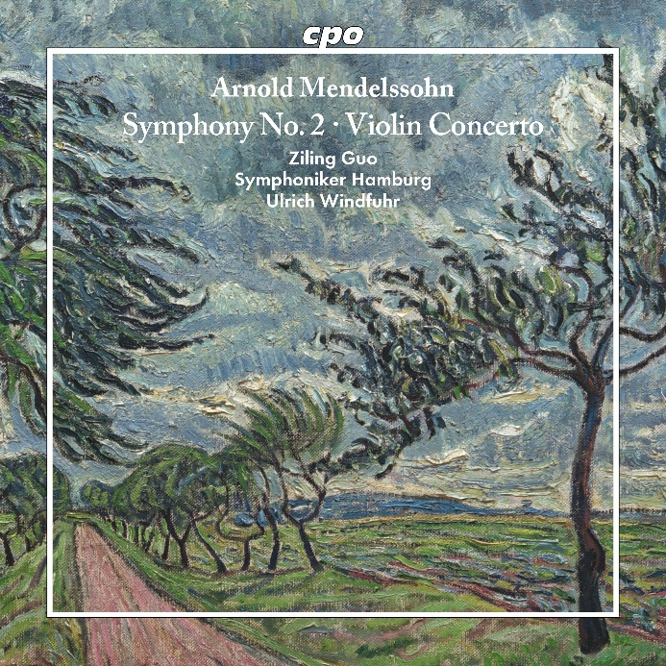

cpo 555 665-2, CD
761203566525

Arnold Mendelssohn
Symphony No. 2 · Violin Concerto
Ziling Guo | Symphoniker Hamburg | Ulrich Windfuhr

Following the example of his distant ‘great uncle’ Felix, Arnold Mendelssohn (1853-1933) was a highly regarded composer, particularly in the field of Protestant sacred music, in which his famous relative had already distinguished himself. In contrast, his serious interest in the classical-romantic instrumental genres only began during the First World War, as if the composer wanted to reassure himself of tradition before all of the old structures collapsed. He was already approaching seventy when he wrote his violin concerto and, immediately afterwards, the second of his three symphonies – two witty masquerades whose broad spectrum between expressive meditation and a cheerful finale offers plenty of room for reminiscence, but not imitation. Mendelssohn juggles with symbols of the past but is never at their mercy. He masters them with ease.

