**Release Date: 17/07/2025**

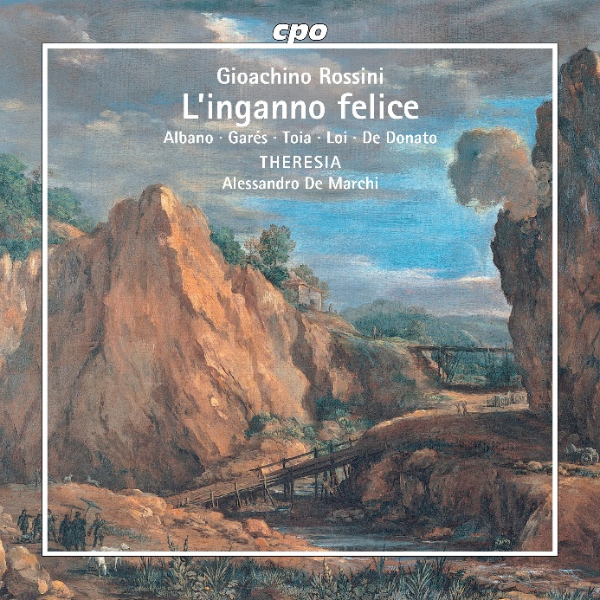

CPO 555 222-2

2 CDs

761203522224

Gioachino Rossini: L'inganno felice

Antonio Garés|Miriam Albano|Giuseppe Toia|Luigi De Donato|Matteo Loi|Theresia Orchestra|Alessandro De Marchi

The wife of a duke resists the advances of a powerful lecher and is “punished” by being cast adrift at sea. A well-meaning overseer of a mining operation rescues the shipwrecked woman and, under a different name, shelters her as his niece for ten years. At last, the duke—widowed for a second time—arrives at the place of her exile. They are reunited, and the villain meets his well-earned fate... Nothing new, one might think. Yet *L’inganno felice* (“The Fortunate Deception”), this one-act opera first performed in Venice in early 1812, is so brimming with Rossini’s most fiery spirit that we forget the familiar plot entirely over the course of its roughly 90-minute runtime: it ignites and sparkles, glitters and whirls with the most beautiful melodies, the most tingling rhythms, and the most furious orchestral surges the master of *The Barber of Seville* was capable of. The festival was far from the only one to be enthralled!