**Release Date: 8/14/2025**

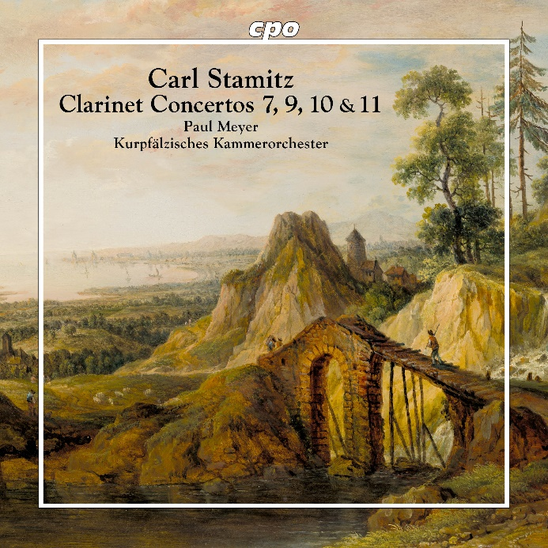

CPO 555 722-2

1 CD

761203572229

Carl Stamitz: Clarinet Concertos Nos. 7, 9, 10 & 11

Paul Meyer; Kurpfälzisches Kammerorchester Mannheim

Whether melting away like a singing gondolier on the Grand Canal or tumbling about like a Eulenspiegel, whether clucking melancholically in the depths like a brooding hen or bouncing acrobatically across the high wire: after the clarinet had outgrown its infant shoes, it was soon "on everyone's lips" thanks to its rapidly expanding possibilities—praised by enthusiastic advocates like Wolfgang Amadeus Mozart, technically advanced by new virtuosos, and entrusted with the most varied tasks by experiment-loving composers. In the front ranks of these pioneers stood Carl Stamitz, one of the first second-generation Mannheimers, who wrote nearly a dozen concertante works tailored to the instrument's slender body, thereby leaving the guild of clarinetists a precious little catechism that can now be heard complete on recording for the first time.