Release Date: 06/11/2025

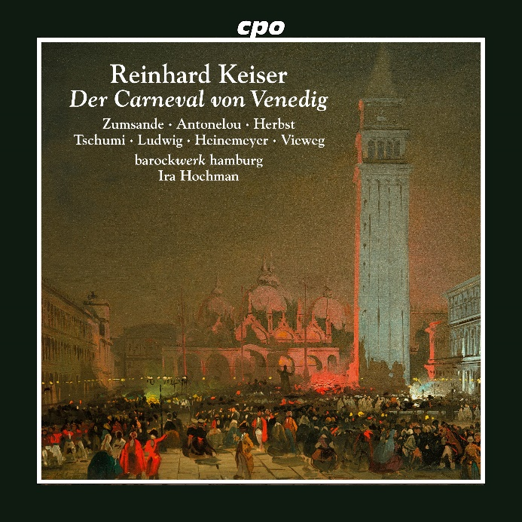

CPO 555 581-2 2 CDs
761203558124

Reinhard Keiser: Der Carneval von Venedig
Hanna Zumsande|Fanie Antonelou|Anna Herbst|Geneviève Tschumi|Mirko Ludwig|Andreas Heinemeyer|Matthias Vieweg|barockwerk hamburg|Ira Hochman

Exactly 318 years ago, Reinhard Keiser composed a box office hit for the Gänsemarkt Opera House – the sensation was entitled Der angenehme Betrug oder der Carneval von Venedig (The Pleasant Deception or the Carnival of Venice) which delighted audiences for nearly a quarter century. On the one hand, this was thanks to a bizarre Carnival story, where two couples fall in love with the wrong partner just before the happy ending à la Così fan tutte, while a German aristocratic couple are happy to settle for "friendship" after all their trials and tribulations. On the other, this was due to the catchy pieces with which the directors of Hamburg's opera house entertained their audiences – simple strophic songs, cute arias, the occasional bawdy piece in the local North German dialect, what more could be desired! Our new production with barockwerk hamburg features musical highlights (without dialogues); these are so extensive that two CDs are necessary to include them all.

