**Release Date: 17/07/2025**

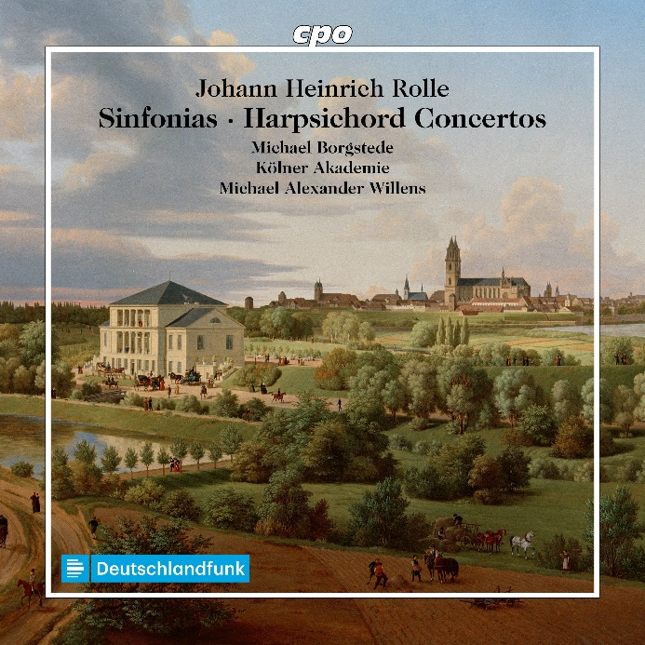

CPO 555 634-2

1 CD

761203563425

Johann Heinrich Rolle: Sinfonias & Harpsichord Concerto

Michael Borgstede|Kölner Akademie|Michael Alexander Willens

When Johann Heinrich Rolle was born, Bach was 31 years old; when he died, Mozart, then in Vienna, was nearing his 30th birthday. In retrospect, it is tempting to count him among the countless “transitional” musicians who distanced themselves from the Baroque, embraced the fashionable galanteries of the time, and thus helped pave the way for the Classical era—as if they had foreseen what was to come. Rolle’s career was indeed typical of his era: organist in Magdeburg, student of law, later active in Berlin—first as a legal advisor, then as a violinist and violist in the service of Frederick the Great—before returning to Magdeburg as organist, cantor, and municipal music director. In addition to a wealth of oratorios and cantatas, he produced a substantial body of instrumental music which, as this symphonic-concertante selection shows, places him firmly within the stylistic currents of his time: light-footed, elegant, spirited, and transparent—in short, so galant that the listener is delightfully engaged from start to finish.