**NEW RELEASE 22/05/2025**

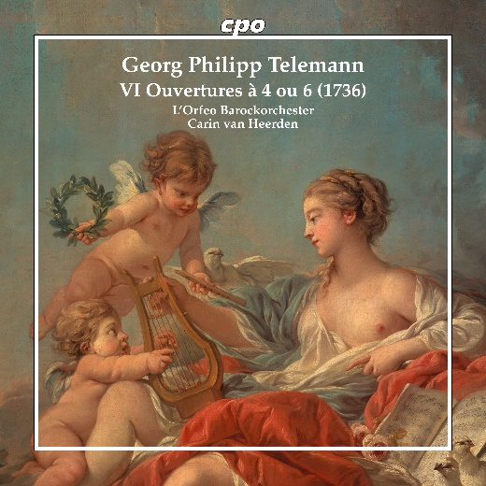

CPO 555 519-2 2 CDs

761203551927

Telemann: VI Ouvertures à 4 ou 6 (1736)

L'Orfeo Barockorchester; Carin van Heerden

Telemann remains a paradox: The deeper one delves into his oeuvre, the more boundless his legacy seems – like entering a mysterious treasure trove where the eyes gradually adjust to the wealth amassed within, yet never fully grasp its true extent. The sheer abundance of his orchestral works and concertos seems to grow exponentially with each new publication. When previously lost compositions unexpectedly resurface – such as these six overtures from 1736, of which only a single printed copy had survived – we are left speechless. Suddenly, an exquisite assortment unfolds before us, featuring "classical" Baroque dance forms interspersed with exotic elements such as the Polonaise and Murky, imaginative character sketches, and various fashionable pieces, all presented in a kaleidoscope of colors. How effortlessly time flies by!