**Release Date: 9/11/2025**

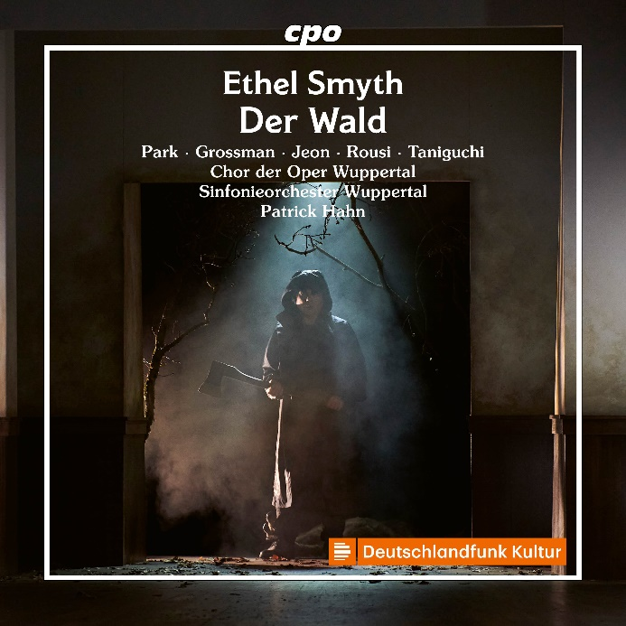

CPO 555 650-2 1 CD

761203565023

Ethel Smyth: Der Wald (Opera in 1 Act)

Samueol Park; Edith Grossman; Sangmin Jeon; Erik Rousi; Mariya Taniguchi; Zachary Wilson; Mira Ilina; Hak-Young Lee; Chor der Oper Wuppertal; Sinfonieorchester Wuppertal; Patrick Hahn

Choirs of spirits, wild passions, unshakeable loyalty, a gruesome act of murder and the eternal triumph of love over death. These are the thoroughly familiar ingredients of the libretto that Ethel Smyth wrote (in German) for her one-act opera Der Wald (The Forest). The music, however, is anything but gruesome. Echoes of Robert Schumann, some striking reminiscences of Richard Wagner and, particularly in the prologue, an unmistakable touch of Art Nouveau carry the drama. It had its premiere at the Berlin Court Opera on 9 April 1902. It was subsequently staged at the Royal Opera House in London and presented with triumphant success at the Met in New York in March 1903. There were standing ovations and a veritable sea of flowers for the 44 year-old Englishwoman, who was the first woman to conquer the classical music temple on Broadway with her work. Talent can achieve anything.