Release Date: 19/02/2026

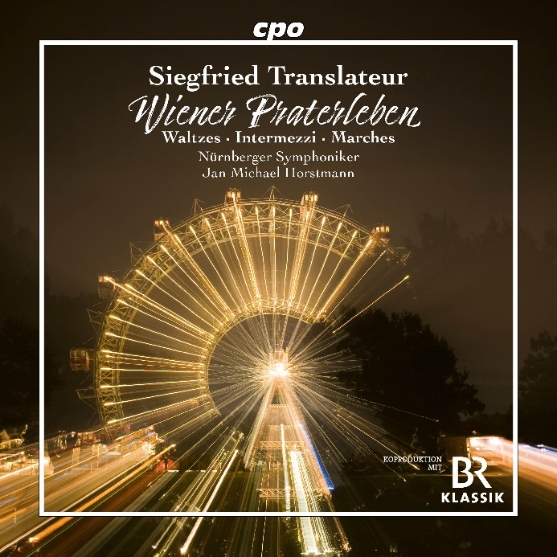

cpo 555 614-2, CD
761203561421

Siegfried Translateur
Waltzes, Polkas, Marches
Nürnberger Symphoniker | Jan Michael Horstmann

"Who doesn't know this loveable master of light entertainment?" asked an admiring critic in 1925, when Berlin composer and publisher Siegfried Translateur celebrated his 50th birthday. Although this rhetorical question does not likely garner even a nominal response today, 150 years after his birth, concert halls were once filled with thunderous applause. The man from Upper Silesia did well for himself with his compositions, not to mention that his student work Wiener Praterleben had just become the hymn of Berlin's Six Day Race and had been transformed to the "Sportspalastwalzer". When Reinhold Franz Habisch aka "Krücke" whistled, the "Nudeltopp" boiled over. But Translateur is so much more. He knows what flowers are dreaming of, he takes a stroll through the big city, waltzes jauntily through life – a charming proponent of a silver era that never really went away.

