**Release Date: 17/07/2025**

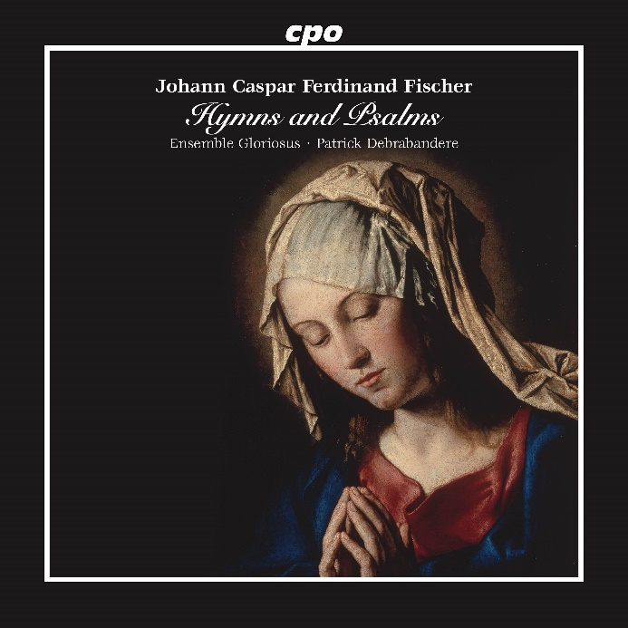

CPO 555 689-2

1 CD

761203568925

Johann Caspar Ferdinand Fischer: Hymns and Psalms

Ensemble Gloriosus; Patrick Debrabandere

Four strings, three trombones, an organ, and a small four-part choir from which solo voices occasionally emerge—these modest forces were all Johann Caspar Ferdinand Fischer needed to shape the litanies, psalms, and hymns assembled here in liturgical order. Their deeply devotional beauty quickly prompts the question: why has he not long been counted among the foremost international masters of the Baroque? True, his keyboard works are moderately well known, and his influence on Bach, Handel, and others has long been acknowledged as historical fact. Yet the full scope and artistry of this Bohemian composer, who first served in Schlackenwerth (now Ostrov) and later in Rastatt, remain far from receiving the recognition they merit. Pioneering efforts such as this recording are likely to spark renewed interest—and with it, more first-rate interpretations.