**Release Date: 17/07/2025**

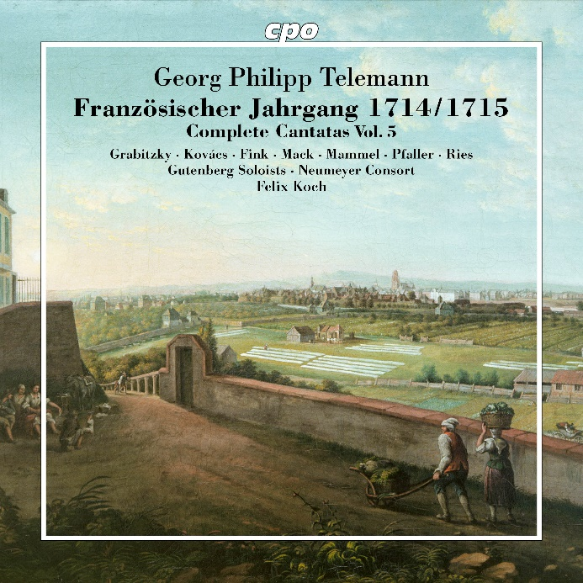

CPO 555 440-2

1 CD

761203544028

Telemann: Französischer Jahrgang 1714/1715 – Complete Cantatas Vol. 5

Helene Grabitzky|Ágnes Kovács|Lieselotte Fink|Jeff Mack|Hans Jörg Mammel|Christoph Pfaller|Nicolas Ries|Gutenberg Soloists|Neumeyer Consort|Felix Koch

With this release, cpo, the Gutenberg Soloists, and the Neumeyer Consort under Felix Koch have now completed an impressive five of the planned seven parts of their shared journey—on the way to what promises to be the first and, for a long time to come, likely the only and uniquely comprehensive recording of the cantatas that the extraordinarily industrious Georg Philipp Telemann composed in 1713/14 for the services at Frankfurt’s Barfüßerkirche. This latest volume is devoted to the feasts of Ascension and Pentecost and also includes additional works designated for the Sundays after Trinity—each of them a smaller or greater marvel, rich in imagery that appeals to all the senses and pays full tribute to the instructive texts of the poetic pastor Erdmann Neumeister.