**Release Date: 9/11/2025**

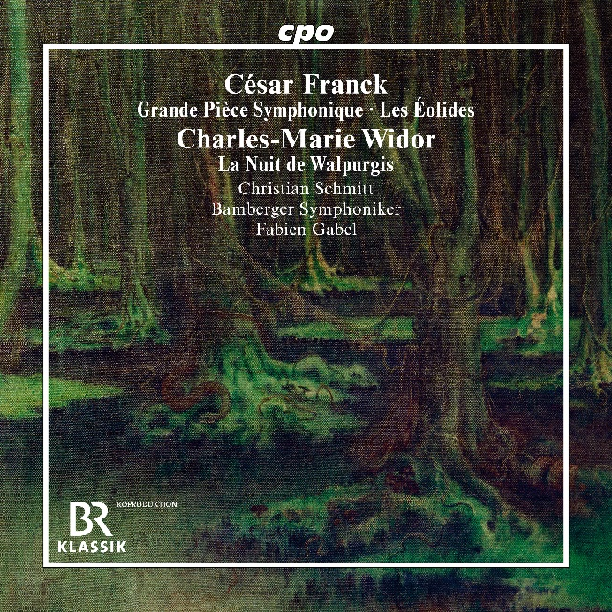

CPO 555 632-2 1 CD

761203563227

C. Franck: Les Éolides & Grande Piece Symphonique -Widor: La nuit de Walpurgis

Christian Schmitt; Bamberger Symphoniker; Fabien Gabel

Anyone who entitles an organ piece a ‘Grand Pièce Symphonique’ should not be surprised if this very title one day is used as a benchmark to determine the legitimacy of this claimed attribute. This is exactly what the organist, composer and pedagogue Zsigmond Szathmáry did at the behest of his young colleague Christian Schmitt when he examined the orchestral possibilities of César Franck's "great symphonic work". The result of this exploration gives us the world premiere of a concert piece in which the king of instruments and its personified registers, i.e. the orchestra, form a captivating synthesis. Next to Franck's well-known tone poem Les Éolides (‘The Daughters of Aeolus’), the programme includes a rarely recorded work by Charles-Marie Widor - a ‘Walpurgis Night’ that easily rivals the most famous witches' dances in the Romantic literature.