Release Date: 9/25/2025

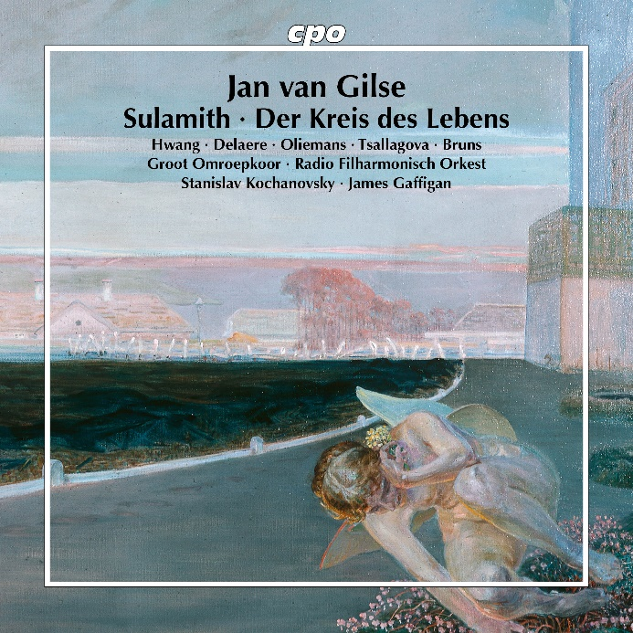

CPO 555 648-2 1 CD
761203564828
Jan van Gilse: Sulamith (Cantata) & Kreis des Lebens (Oratorio)
Groot Omroepkoor; Radio Filharmonisch Orkest; James Gaffigan; Stanislav Kochanovs

When Jan van Gilse completed his studies in Cologne in 1902, he devoted himself to his prizewinning first symphony along with a dramatic scene based on the prose poem Sulamith by Prince Erich von Schönaich-Carolath, in which Satan realises that there is still love on earth despite his machinations. Judging by his impressive music, this must have been the innermost conviction of the composer, who never found it easy in his life to bridge the gap between his German education and the prevailing taste of his fellow countrymen. Combative and vulnerable, quick-tempered and desperate, he strove for a truth that few heard - a loner even when, in 1929, he wrote the poignant Kreis des Lebens (Circle of Life) after Rainer Maria Rilke, which had had to wait for a hundred years to receive adequate performance and deserved recognition. Now it has arrived.

