**Release Date: 8/14/2025**

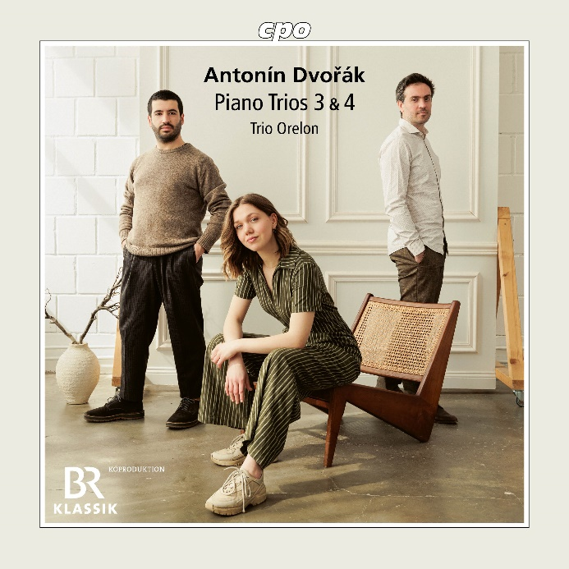

CPO 555 688-2 1 CD

761203568826

Dvorak: Piano Trios 3 & 4

Trio Orelon

Anyone who has survived the cursed seventh year may hope for a rosy future. The Orelon Trio, founded in Cologne in 2018, has just crossed this significant threshold—though its members Judith Stapf (violin), Arnau Rovira i Bascompte (cello), and Marco Sanna (piano) never had to find their footing together: within a short time, these "meteoric risers" made a name for themselves, quickly guest-performing at renowned venues; high-caliber competition successes followed naturally (ARD, Melbourne, Graz), their first recordings and enthusiastic response from professional circles were not long in coming. How could it be otherwise, when the three musicians' "oreloj" (Esperanto for: ears) are so excellently attuned that they can perceive unheard-of things even in familiar repertoire. This first ***cpo*** release by the Orelon Trio leaves no doubt about that.