Release Date: 8/14/2025

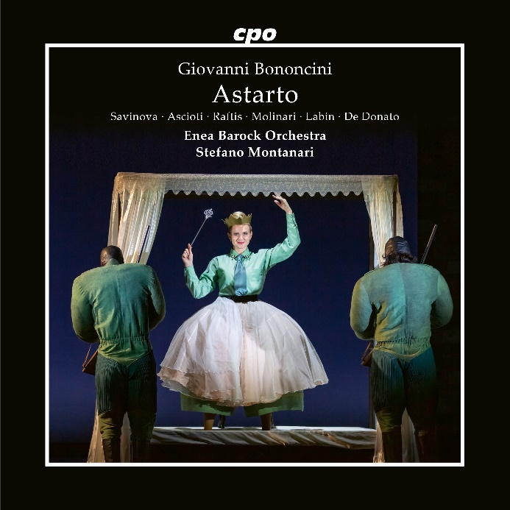

CPO 555 591-2
3 CDs
761203559121
Giovanni Bononcini: Astarto (Opera in 3 Acts)
Francesca Ascioti; Dara Savinova; Anna Maria Labin; Paola Valentina Molinari; Theodora Raftis; Luigi de Donato; Enea Barock Orchestra; Stefano Montanari

That Elisa, Queen of Tyre, wishes to marry her beloved naval hero Clearco to protect him from Astarto—the son of the rightful ruler whom Elisa's father killed—sounds manageable enough. That the chosen bridegroom and the opera's title character are identical makes matters considerably more complicated. These baroque entanglements resolve themselves only through protracted, labyrinthine intrigues, seething jealous outbursts, ingenious document forgeries, and perilous conspiracies. The question, however, of why Giovanni Bononcini, the work's composer, was regarded in his time as the very embodiment of grace, and why he was considered Handel's most dangerous adversary on London's stages—this question was answered swiftly and convincingly at the 2022 Innsbruck Festival: he could pull every emotional register for which audiences storm(ed) the opera houses.

