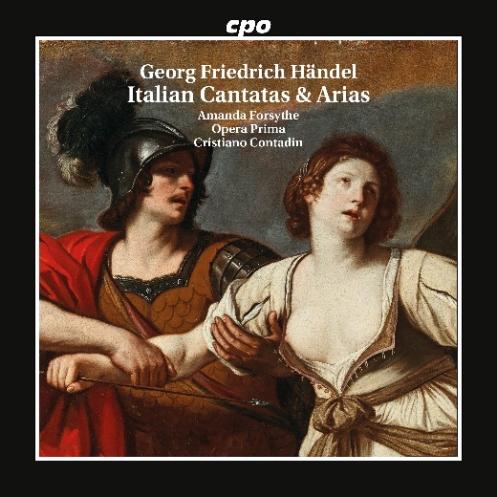

CPO 555 616-2 1 CD

761203561629

Händel: Italian Cantatas & Arias

Amanda Forsythe; Opera Prima; Cristiano Contadin

When the 18-year-old Georg Friedrich Handel arrived in Hamburg to immerse himself in the dazzling world of opera, he sat in the violin section as though he could not count to five, according to his friend Johann Mattheson. A year later, he presented his first stage work, and by the age of 21, he had already won the hearts of the Italians – a prodigy of boundless versatility to whom no task was too difficult. Even where the clergy prohibited opera performances, the "dear Saxon", as they called him, ignited dramatic sparks. The two cantatas – one about the sorceress Armida, abandoned by her beloved, and the other about Emperor Nero’s mother, condemned to death – are intense monodramas that continue to spellbind audiences today, especially when staged by an artist like Amanda Forsythe. One is grateful for the instrumental interludes that provide moments of respite between these captivating "pocket operas”.