**Release Date: 8/14/2025**

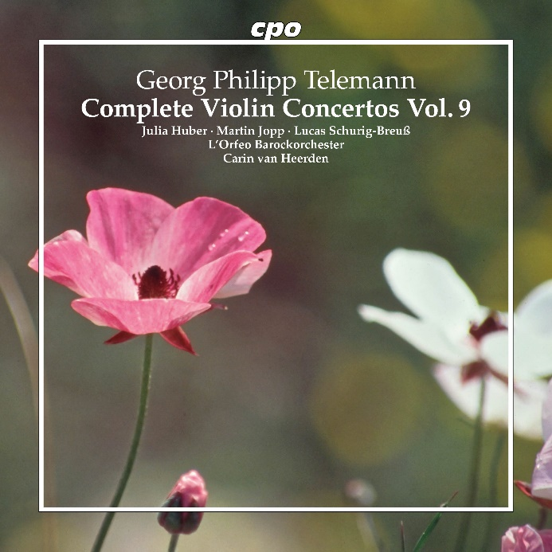

CPO 555 699-2

1 CD

761203569922

Telemann: Complete Violin Concertos Vol. 9

Julia Huber · Martin Jopp · Lucas Schurig-Breuß  
L'Orfeo Barockorchester  
Carin van Heerden

Everything has an end sometime. Similarly, this chapter from the great book of Georg Philipp Telemann, which holds a significant place in our label's repertoire, is also noteworthy. After two decades, we have now recorded all the violin concertos that this artesian spring of music committed to paper with overflowing imagination throughout his lifetime. This presents more than three dozen entertaining works, some in expanded suite (overture) form, others in the standard three-movement structure—but always rich in subtle surprises and demanding solos involving up to four violins. This ninth and final volume is once again devoted to concertante duos and contains, as it were, as a bonus, "the" Viola Concerto in G major, which until our series appeared was widely regarded as Telemann's most "popular" contribution to the genre. Now, however, entirely new perspectives open up...