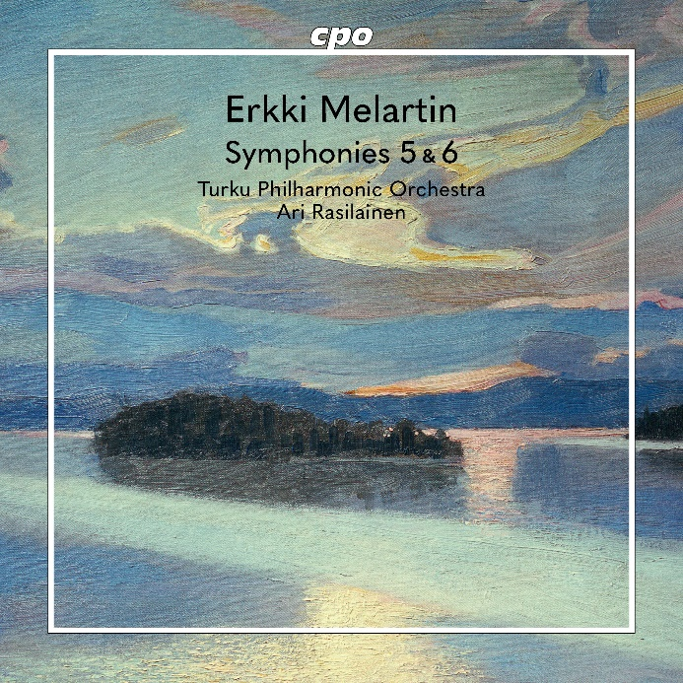

CPO 555 558-2 1 CD

761203555826

Erkki Melartin: Symphonies 5 & 6

Turku Philharmonic Orchestra; Ari Rasilainen

As the founding father of Finnish music, Jean Sibelius is the measure of all things to such an extent that an outside observer may easily miss the abundance of talented masters who also practiced the art of composition quite successfully in the land of a thousand lakes. One of them was Erkki Melartin. Not ten years younger than the composer of Finlandia, he also left us a significant oeuvre that repeatedly begs a comparison to his older colleague – of course, it is a comparison whose results are subject to debate. To be fair, we can discover a phrase here or there that reminds us of Sibelius; occasionally, some of Mahler's vocabulary may have sneaked in as well; but the persona whose legacy is six mighty symphonies has blazed his own independent trail away from the Romantic tradition, leading us relentlessly to an unheard cosmos.