**Release Date: 17/07/2025**

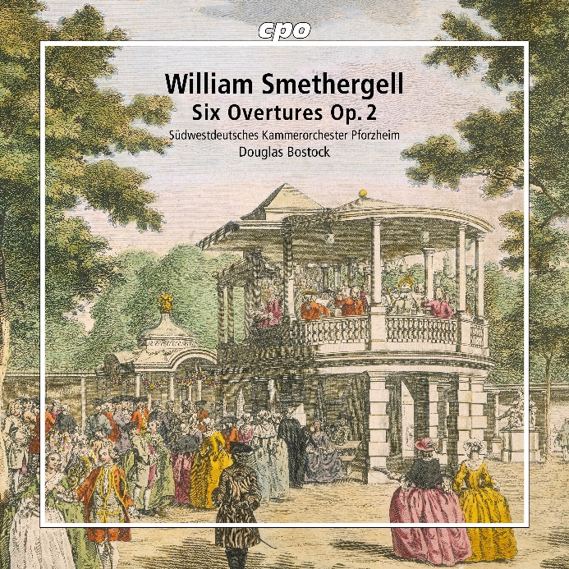

CPO 555 541-2

1 CD

761203554126

William Smethergell: Overtures Vol. 2

Südwestdeutsches Kammerorchester Pforzheim; Douglas Bostock

William Smethergell’s oeuvre presents an intriguing challenge. Since little more is known of his life than his birth date and the fact that he worked as an organist at two London churches and as a violist at the Vauxhall Pleasure Gardens, we must form our impression of him solely through his music. That impression is certainly favorable—at least if we go by the two sets of six overtures published as Op. 2 (1778) and Op. 5 (1780): “Brilliantly scored, richly orchestrated works—ingenious, lively, and full of variety, bearing witness to Smethergell’s great melodic inventiveness,” was the verdict of *klassik-heute* on Op. 5 (CD 555 540-2), which Douglas Bostock and the Southwest German Chamber Orchestra Pforzheim introduced to us in 2023. The same ensemble now completes the dozen with the equally attractive Op. 2, a collection widely admired in late 18th-century London and beyond, and is now winning new friends.